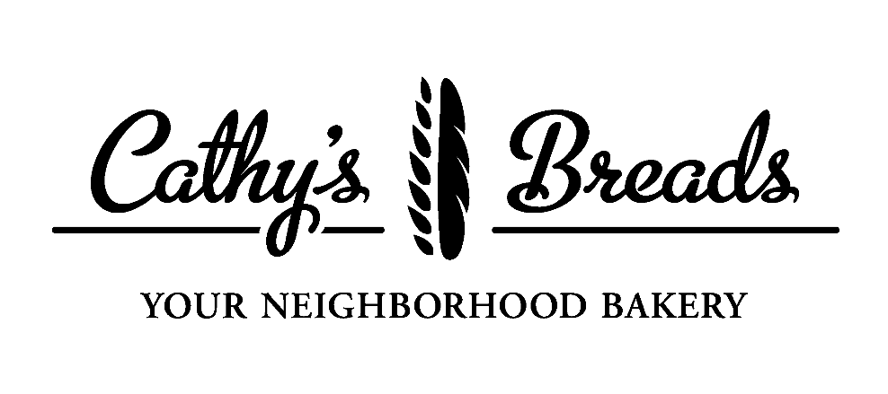
Micro-Bakery Training Program

Fundamentals of Bread Baking Course
June to October 2024

Program Goal:
The goal of the Cathy’s Breads Micro-Bakery Training Program is to develop a pool of skilled bakers able to produce artisan breads and fine-crafted pastries to sell in the Hays, Kansas community.

Course Purpose:
The purpose of this first course is to introduce students to the technical information necessary for the consistent production of fine quality breads. Mastery of hand skills will be equally important, and students will have significant focus in this area. Additionally, students will be introduced to what’s involved in bringing products to market from a micro-bakery setting. The combination of technical information, skills practice, and real-time production will combine to offer a sound practical foundation for the student.

Course Design

There are four parts to the course:

- Training Weeks
Students will learn about and practice the fundamentals of bread baking in Cathy’s Bread’s home-based micro-bakery during a two-week 50-hour training. The training will include some lectures, but mostly hands-on learning through the production of many different types of yeast-based breads. Breads produced will include straight doughs, yeasted pre-ferment doughs, lean and enriched doughs, doughs with whole grains and add-ins, and doughs at various hydration levels. (Note: sourdough breads will be covered in another course). Class size will be limited to three students, allowing for close and immediate supervision of learning and skills development.

- Market Weeks
Students will have the opportunity to put their learning into action by planning the market menu and production schedule, producing doughs, baking goods, and selling wares for two markets during the Downtown Hays Market season. Students will be operating as a group under Cathy’s guidance and using Cathy’s Breads’ facilities. Profits earned from market sales will be split among student participants according to hours worked.

- Follow Up/Continuing Education Days
Students will have the opportunity to consult with Cathy on their bread baking journey. Cathy will maintain a group WhatsApp chat for students to ask questions, trouble shoot problems, and test out new bread ideas. In addition, Cathy will provide day-long training on specific topics (specialty breads and techniques) that students are interested in. Two of these days will be offered in the fall following the Market Weeks.
- Evaluation
At the end of the course, each student will receive written evaluation on their progress along with recommendations for future learning and skills development opportunities.

After reassessing the model, Cathy’s Breads will offer continuing courses using this similar design on the topics of Sourdough Baking and Viennoisserie.

Course Outcomes

After completing Fundamentals of Bread Baking, students should be able to:
- Explain and demonstrate the main steps of bread making
- Understand the roles different ingredients play in the making of bread
- Read a formula and describe the type of bread it will yield
- Understand and use baker’s percentages
- Describe different mixing techniques, and demonstrate mixing doughs to appropriate level of development depending on type/purpose
- Describe the fermentation process, and determine when bulk fermentation and final proofing are complete
- Shape baguettes, boules, batards, rolls, pan loaves and braids with consistent accuracy and speed
- Demonstrate correct scoring and baking procedure depending on dough type
- Identify and troubleshoot breadmaking errors at various stages of the process
- Understand the regulations for running a home-based micro-bakery
- Set and carry out a mixing and baking schedule for a market setting

- In addition, students will gain familiarity with the following equipment of a micro bakery:
- Mixers: KitchenAid, Ankarsrum, Hobart (20qt), FAMAG (40qt)
- Ovens: KitchenAid Convection; Rofco B40; Rackmaster 2020

Selection Criteria:
The ideal participant would have already started their bread journey on their own, having at least experimented with yeast-based or sourdough breads. This is not an enrichment class for home bakers to improve their skills, but a training for accomplished bakers who would like to sell their wares to other people on a regular basis. Students could be talented home bakers or current food service workers ready to take the next step into the baking business. Students should have the ability to dedicate significant time and attention to the course, including practice at home. Students should live in Hays, Kansas and plan on staying in the area. Students must be 18 years old and/or a high school graduate. Ideally students will have completed the online ServSafe Food Handler Certification course and test before the start of the course. Prospective students will fill out an application, followed up with in-person interviews of selected candidates.

Course Dates/Schedule:

  - A Two-Week Training (50 hours)--June 3rd-14th, Monday - Friday, 7:00am-12:00noon
(timeframe is tentative based on admitted students’ availability)
Class maximum: three students.

  - Two Downtown Hays Market Baking Weeks (students participate in both markets; profits to be split according to hours worked)

    - For June 29th Market, prep will occur between June 26th – June 28th; (hours to be selected by sign-up). A mandatory market planning meeting will be held on June 15th, time to be determined.

    - For August 24th Market, prep will occur between August 21st-August 23rd (hours to be selected by signup). A mandatory market planning meeting will be held on August 15th, time to be determined.

  - Two Follow up Training Days (students participate in both)

  - One in September, one in October. Dates/times to be determined by participants.

SAMPLE DAY OUTLINE
7:00am Gathering/Coffee/Pastries
7:15-8:00am Morning Lecture on various aspects of bread making
8:00-9:30am Hands-on in the bakery (mixing, shaping)
9:30-9:45am Break
9:45-11:30am Hands-on in the bakery (mixing, shaping, baking); Prep for next day
11:30-12noon Product tasting, Questions, Review of Day, Preview of next day, Cleanup

Course Facilities/Materials:
Training takes place in Cathy’s Breads bakery (1509 Elm Street). Equipment includes a mix of home kitchen and small bakery kitchen appliances appropriate for micro-bakery production. All necessary ingredients, formulas and major equipment for training will be provided. Each student will receive their own notebook of formulas and resources used during the training. Products baked during class will go home with students.

Course Application/Cost:
A course application is available on the Cathy's Breads website. Applications are due by Monday, April 8th. Applications will be reviewed as they are submitted, with promising candidates invited for in-person interviews. All applicants will be informed of selection status by Monday, April 22nd.
Cost for the course (two weeks’ training, two markets, two follow up training days, and all necessary materials and ingredients) is $750. Limited scholarships may be available for qualified individuals.

Required Student Materials:
- Course text: Jeffrey Hamelman, Bread: A Baker’s Book of Techniques and Recipes, 3rd ed. (Wiley, 2021).
- Portable Scale (weight capacity at least 10lbs; 1g units; tare feature)
- Instant read thermometer
- Flexible Dough Scraper
- Metal Bench Divider
- Apron
- Light, long-sleeved shirt or chef’s coat to provide protection when loading ovens (optional but recommended)
- Pencil, pen, and several black Sharpie markers
- Water bottle (optional)

Course Instructor:
Since 2013, Cathy Drabkin has run Cathy’s Breads, a successful home-based micro-bakery in Hays, Kansas offering artisan-style breads and fine-crafted sweets, using locally sourced organic flours, natural ingredients, and time-honored methods. Cathy’s Breads has developed a loyal following of customers from Hays and surrounding areas and was featured in the January 2022 issue of MidWest Living Magazine. Cathy’s Breads employs a part-time assistant. Cathy has attended numerous professional baking trainings at the San Francisco Baking Institute and the King Arthur Flour Baking Center. She taught baking and cooking classes for the Hays Recreation Commission for a number of years and received the HRC Instructor of the Year award in 2017. Cathy is offering this training program in the hope that her Hays area customers can be sure of a continuing source of fine baked goods after she retires in several years!

Contact Info:
Cathy Drabkin
Cathy’s Breads
1509 Elm Street
Hays, KS 67601
cathysbreads.com
cathy@cathysbreads.com
785-639-3060

Please feel free to contact Cathy with any questions about the program or application process.

