Cheese Fondue Stuffed Roasted Squash
From Food52.com
Serves 6-8 as an appetizer
- 1 squash or sugar pumpkin, about 3 1/2 pounds (I used a “buttercup squash”)
- 1 Cathy’s Breads baguette
- 3ounces Emmental cheese, coarsely grated
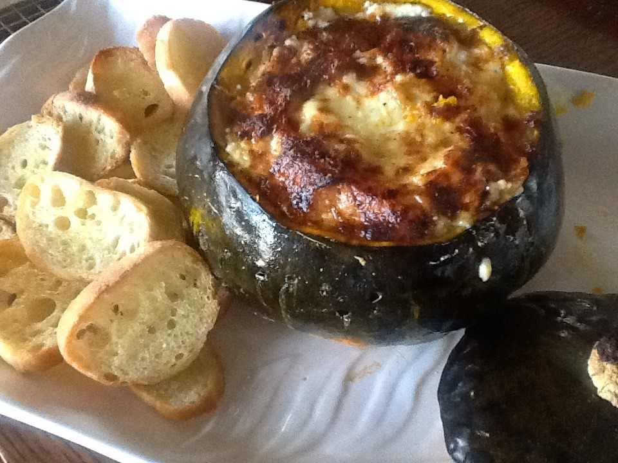
- 3ounces Gruyère cheese, coarsely grated
- 1cup heavy cream
- 1large pinch of freshly grated nutmeg
- Kosher salt and freshly ground black, to taste pepper
- Honey, to taste
- Preheat oven to 450°F with rack in lower third.
- Slice the baguette into ¼-1/2 inch slices. Cut half of them into 1/2 inch cubes.
- Toast the baguette slices and cubes in a single layer on a baking sheet in oven until tops are crisp (bread will still be pale), about 7 minutes. Transfer to a rack to cool.
- Remove top of pumpkin by cutting a circle around the stem with a small sharp knife. Scrape out seeds and any loose fibers from inside pumpkin with a spoon (including top of pumpkin; reserve seeds for another use if desired). Season the inside with 1/4 teaspoon salt and a drizzle of honey.
- Whisk together cream, nutmeg, 1/2 teaspoon salt, and 1/4 teaspoon pepper in a bowl. Mix together cheeses in another bowl.
- Put a layer of toasted bread cubes in bottom of pumpkin, then cover with about 1/2 cup cheese and about 1/3 cup cream mixture. Drizzle some more honey on top of the cheese and cream. Continue layering bread, cheese, cream mixture, and honey until pumpkin is filled to about 1/2 inch from top. (You may have some leftover bread, cheese, and cream left over.)
- Cover pumpkin with top and put in an oiled small roasting pan. Brush outside of pumpkin all over with olive oil. Bake 1 hour and then remove the top.
- Return the rest of the pumpkin to the oven and bake until the top of the cheese is browned and bubbly, about 10 to 15 minutes. Serve with the rest of the baguette slices. Also works to have a darker-flavored rye bread to serve with the fondue.

