RICH BREAD PUDDING WITH CRISP CINNAMON-SUGAR TOPPING
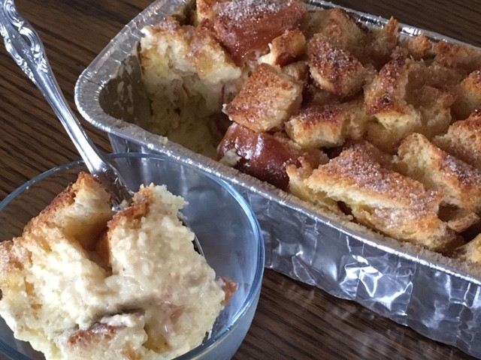
For 8-9” square pan

Ingredients:

2 large eggs plus 1 yolk
6T sugar
1 ¼ cups whole milk
1 ¼ cups heavy cream
1 ½ T bourbon
1 ½ teaspoons vanilla extract
3/8 teaspoon nutmeg
1/8 teaspoon salt
12 ounces Challah (or other good quality bread), sliced ½” thick and cut into 1-1 ½ ” squares, divided
Butter for the pan

For topping:
1T melted butter, unsalted
Cinnamon Sugar (1T sugar, ¼” teaspoon cinnamon)

Preheat oven to 325. Butter the pan.
If bread is not stale or dried, toast cubes briefly until dry to touch, but not colored. About 5-7 minutes in 325 oven.

Whisk eggs, yolk and sugar in medium bowl to blend well. Whisk in milk, cream, bourbon, vanilla, nutmeg and salt. Stir in 8 ounces of the bread (about 3 cups), reserving the remaining 4 ounces for the topping. Mix thoroughly to moisten. Let stand 20 minutes. Pour mixture into baking dish. Take remaining bread cubes and toss with melted butter and cinnamon sugar, coating well. Place cinnamon sugar cubes on top of bread pudding, gently pressing on top. Bake until pudding is deep golden brown, and jiggles very slightly at the center when shaken, about 45-50 minutes. Let cool until set but still warm (about 45 minutes). Serve.

Sauces

QUICK RASPBERRY SAUCE
Thaw a small (12oz) bag of frozen raspberries; run through a food mill or sieve to remove seeds and create puree. Combine with ½ cup of raspberry preserves to create sauce consistency. Taste and add sugar to desired sweetness. Add a squeeze of lemon juice if desired.

CARAMEL SAUCE
Bring ¾ cup sugar, ½ cup water and ¼ cup light corn syrup to boil until sugar dissolves. Maintain a stead medium boil until mixture turns light straw color. Carefully watch as syrup as it takes on color, adding cream and stirring constantly once it reaches a medium brown color. Continue cooking till a smooth caramel sauce is achieved.

CHOCOLATE SAUCE
Bring 8 oz of cream to boil. Pour over 9 oz of chopped semi-sweet or bittersweet chocolate. Let sit 1-2 minutes, then careful stir, from the center outwards, until well mixed.

LEMON CURD SAUCE
In a small saucepan, combine 1/3 cup sugar, 1/3 cup lemon juice, 2 teaspoons lemon zest, and 2 large eggs (at room temperature). Add ¼ cup room temperature butter and cook over low heat, stirring continuously with a whisk, until the first bubble appears on the surface of the mixture and the curd is thick enough to hold marks of the whisk, about 6-8 minutes. Strain the lemon curd through a fine-mesh strainer if you don't want the lemon zest in the curd. Transfer the hot lemon curd to a bowl or jar and cover the surface with plastic wrap. Refrigerate until cold, then take off the plastic wrap and replace with a lid.

