Reuben Dip for Bread Bowl
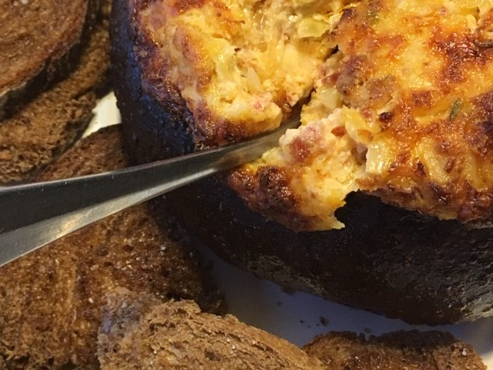
½ cup mayonnaise
3T ketchup
2T finely chopped dill pickle
3 cups Swiss cheese (9 oz)
1 cup sauerkraut, lightly squeezed to remove excess liquid; chopped
4 oz cream cheese, at room temperature
6 oz corned beef or pastrami, chopped
½ tsp caraway seeds
1/16 tsp cayenne
1 large round of Cathy’s Country Loaf or pumpernickel bread

Mix mayo, ketchup and dill pickle in a bowl. Add the rest of the ingredients into the mixture; stir until combined. Hollow out the bread loaf, leaving a ½-inch thick shell. Reserve the cut-out bread. Fill the loaf with the dip and transfer to a baking sheet. Bake the bread bowl until the cheese melts and the top is golden brown, 30-40 minutes in a pre-heated 350 oven. While the dip bakes, slice the reserved bread into pieces and arrange on a separate baking sheet; drizzle with olive oil and sprinkle with salt. During last 10 minutes of baking, put the reserved bread slices in the oven to toast.

Serve bread bowl dip with the toasted bread, crackers and/or crudities.

Bacon Beer Cheese Dip for Bread Bowl

8 oz cream cheese, at room temperature
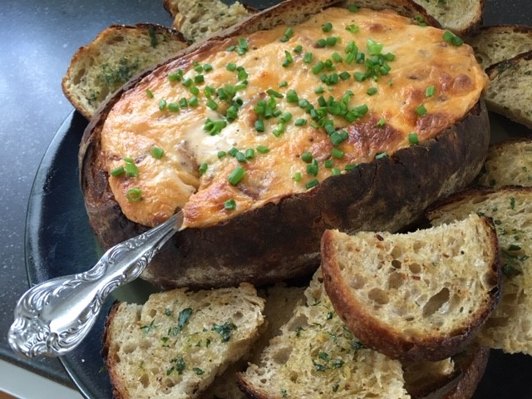
8 oz of lager or beer of choice, plus 1 T
1T whole grain mustard
1tsp Worcestershire sauce
1T cornstarch
8oz swiss cheese, shredded
8oz sharp cheddar cheese, shredded
8 slices bacon, cooked & crumbled
3 cloves garlic
¼ cup mixed herbs (chives, parsley, dill, etc)
3T olive oil
Chopped chives, to top
1 large loaf Cathy’s Country Loaf

Preheat oven to 375. Slice off the top of the bread and hollow out the inside to create a bowl. Save the top for later. In a large bowl, mix together cream cheese and 1 cup of beer, until combined. Combine the remaining 1 Tablespoon of beer with the cornstarch. Add the cornstarch mixture to the cream cheese mixture, along with the mustard and Worcestershire sauce. Fold in the shredded cheeses, then the bacon. Fill the bread bowl with the mixture and transfer to a rimmed baking sheet. Bake in oven about 30 minutes until cheese is melted and bubbling.

While the dip bakes, cut the reserved bread into slices and arrange on a sheet pan. In a small bowl, combine the olive oil and fresh herbs. Spoon the mixture onto the bread slices and bake during the last 5-10 minutes while the bread bowl bakes. Garnish the bread bowl with chopped chives and serve warm with the bread slices, pretzels and/or broccoli.

