Muffaletta Olive Salad
Make 3-5 days in advance to allow flavors to meld.
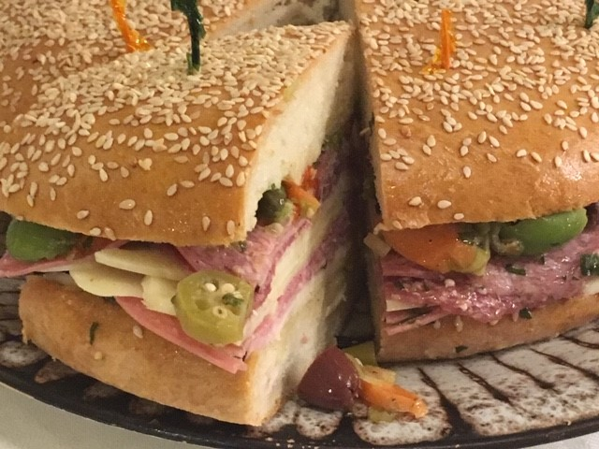

1 ½ cups green olives, pitted
½ cup calamata olives, pitted
1 cup Giardiniera, coarsely chopped (Giardiniera is pickled
cauliflower, carrots, celery, pepperoncini—
available at Dillons)
¼ cup pickled okra (optional), chopped
1T capers
1 garlic cloves, thinly sliced
1/8 cup celery, thinly sliced
1T Italian parsley, finely chopped
1T fresh oregano, or 2 tsp dried
1 tsp crushed red pepper flakes
3T red wine vinegar
¼ cup roasted red peppers, chopped
1T green onions, thinly sliced
Freshly groud pepper to taste

Crush each olive lightly on cutting board. Combine all ingredients. Cover with 1 to 1 ½ cups extra virgin olive oil. Put into a bowl or jar, cover and let the flavors marry.

Muffaletta Sandwich
Serves 8-12

1 large round of Cathy’s Muffaletta Bread
1 recipe of Muffaletta Olive Salad
6oz sliced provolone cheese
6oz sliced mozzarella cheese
8oz sliced mortadella, or ham
8oz sliced Genoa salami

Split the Muffaletta round horizontally. Brush each side with oil from the olive salad. Stack alternating layers of cheese and meats on the bottom round, top with the olive salad, and top with bread. Wrap the entire sandwich loaf up in plastic wrap for at least 30 minutes and up to 2 hours. Slice the muffaletta sandwich into wedges, secured with frilled toothpicks, to serve.

